- 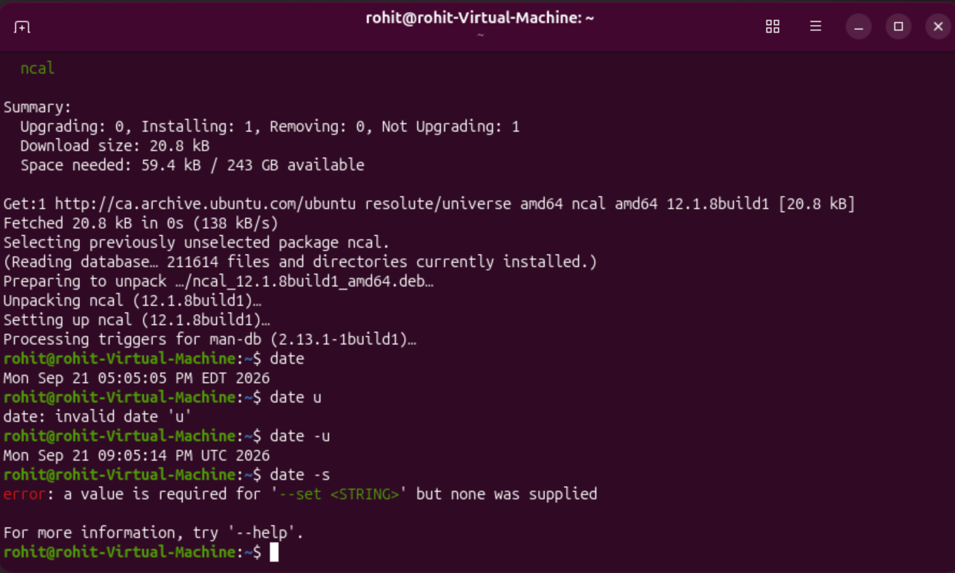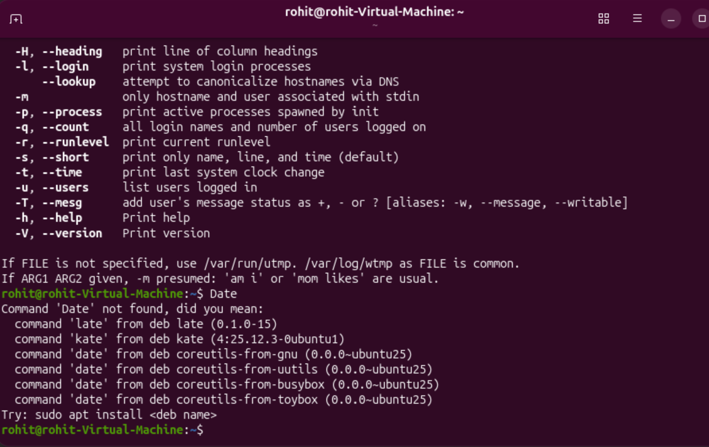
When I type ‘date’ into the terminal, it produces the local time, which would be Eastern Standard Time. When I type ‘date -u’ into the terminal, I get the Universal Time. When I type ‘date -s’ into the terminal, it produces an error that says “A value is required for ‘- -SET <STRING>’, but none was applied”.

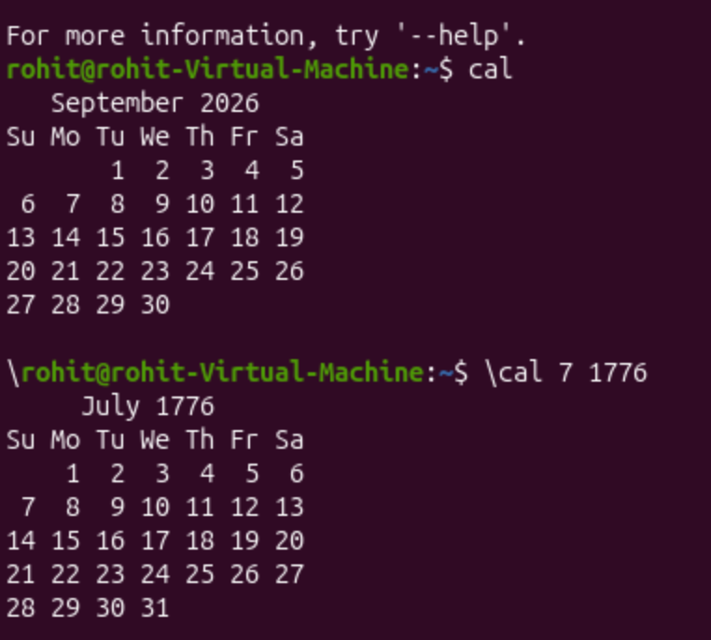
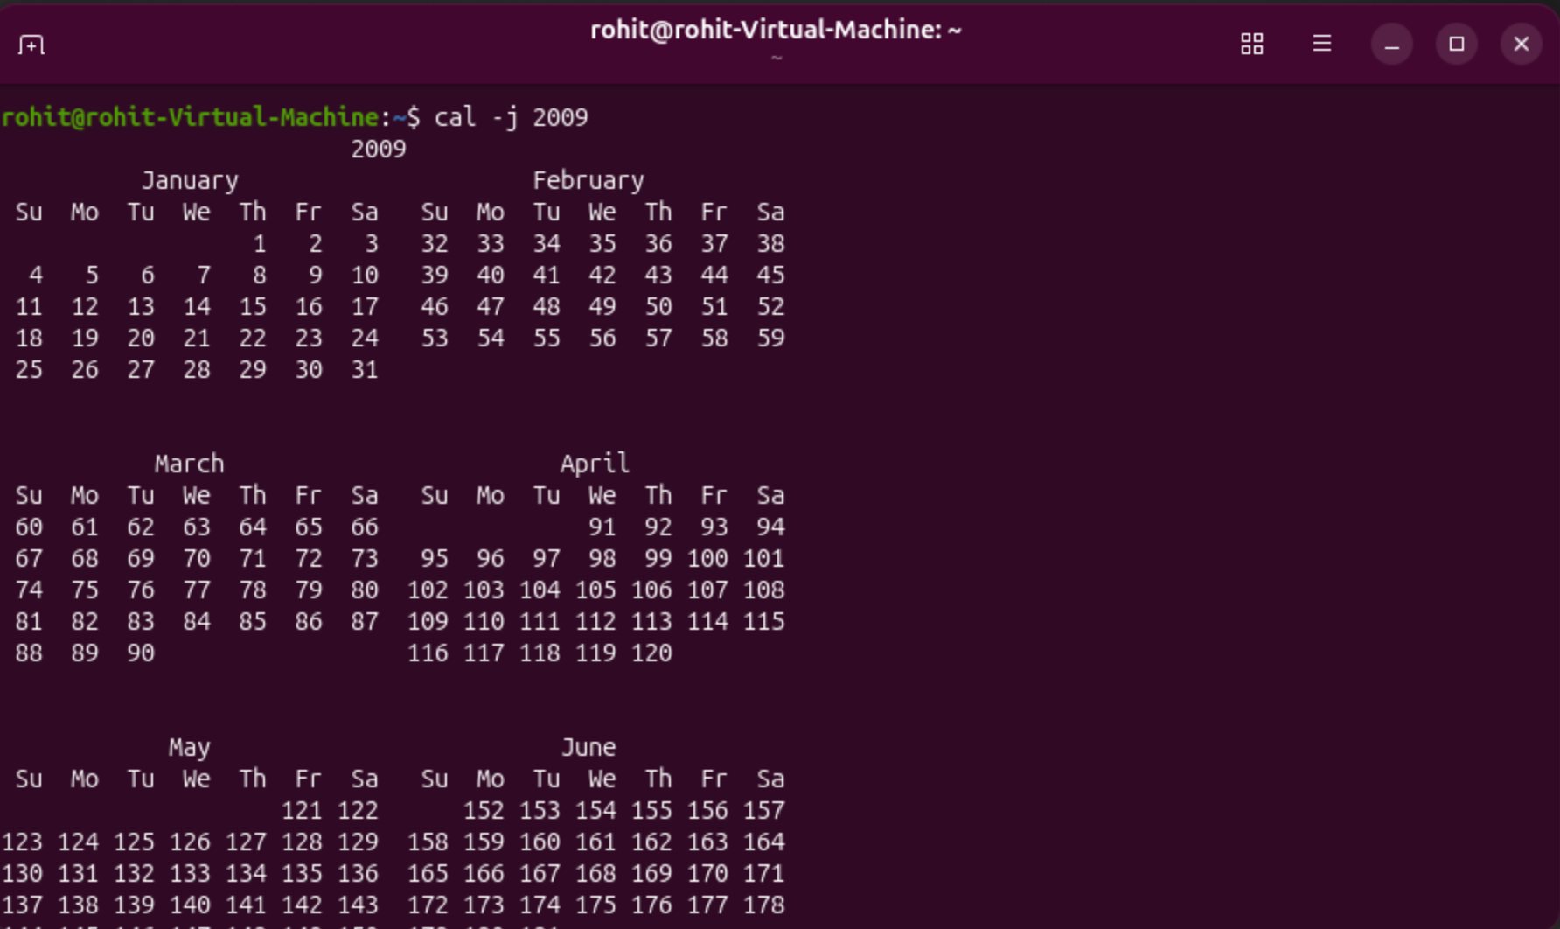
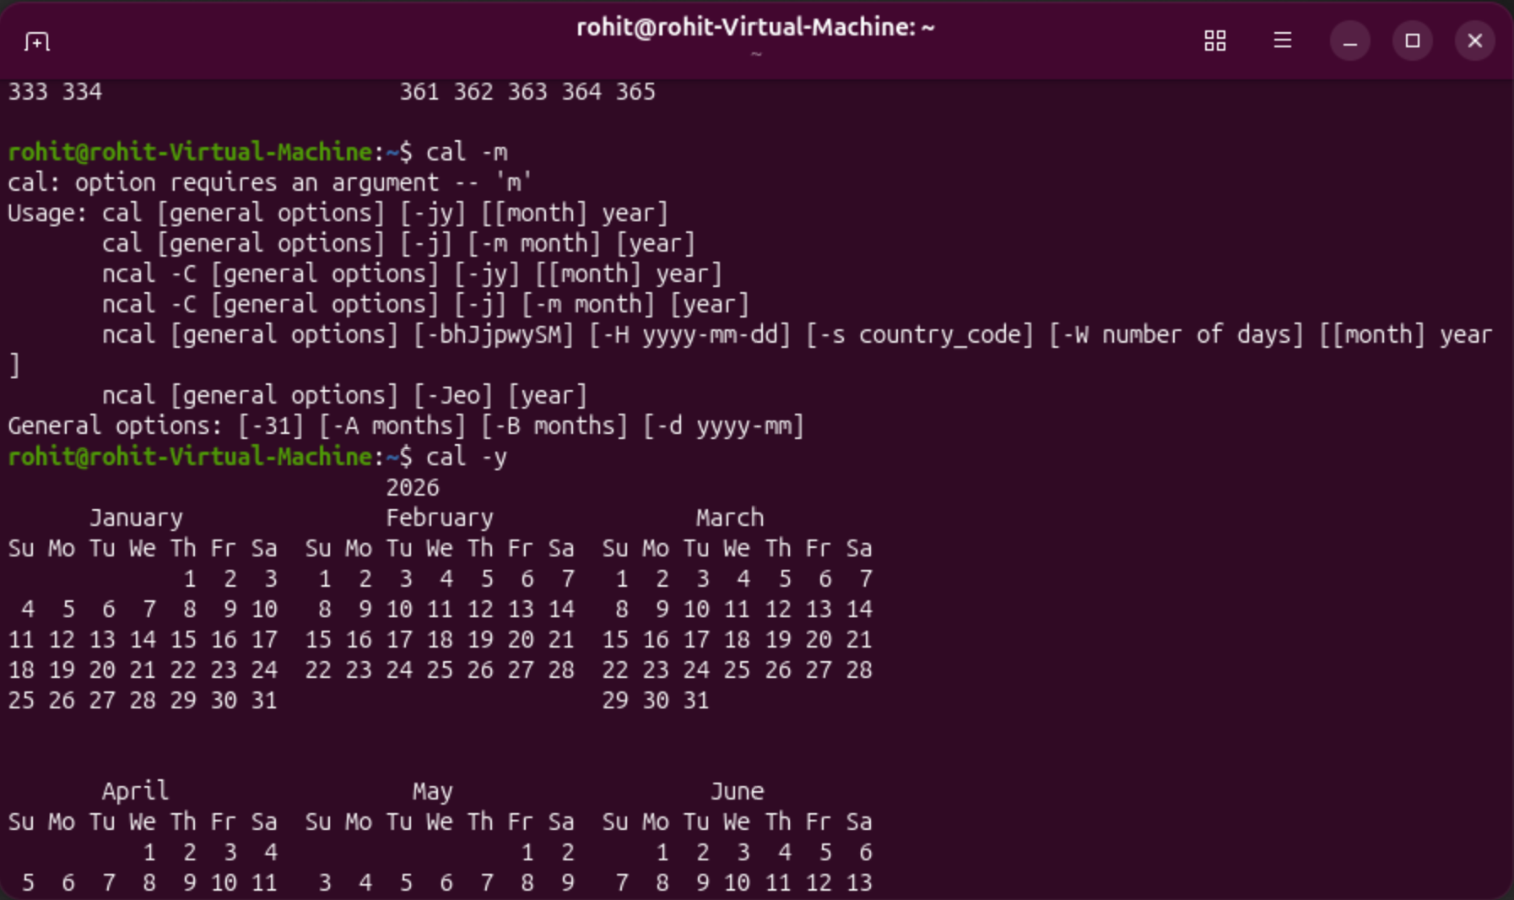
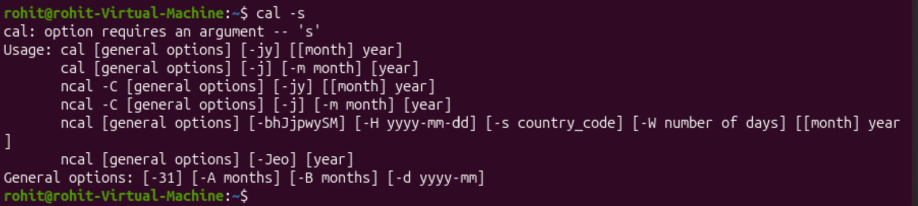
Typing ‘cal’ into the terminal prompt shows a calendar of the current month and year. Typing ‘cal 7 1776’ into the terminal prompt shows a calendar from July 1776. Typing ‘cal -j 2009’ into the terminal shows a calendar from the whole year of 2009, with the days of each month numbered from 1-365. Typing ‘cal -s’ or ‘cal -m’ into the terminal asks for an argument. Typing ‘cal -y’ into the terminal shows the entire calendar for the current year.

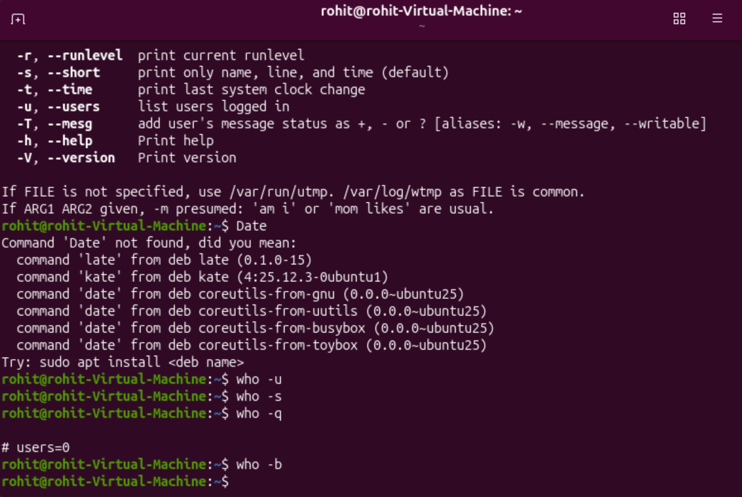
When I typed ‘who, who -u, who -s, who -b’ into the terminal, it did not produce any output. When I typed ‘who -q’ into the terminal however, it gives the output ‘# users=0’.
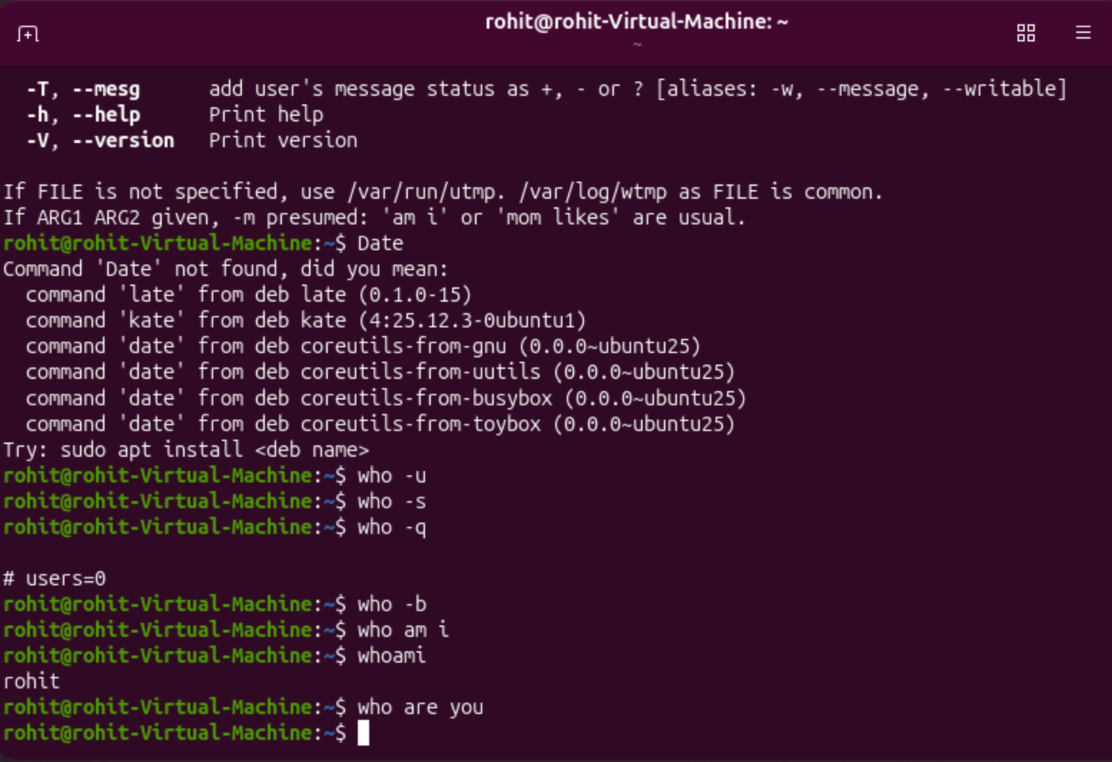
When I type ‘who am I’ or ‘who are you’, it does not produce any output. When I type ‘whoami’ however, it outputs the name of the user.

- 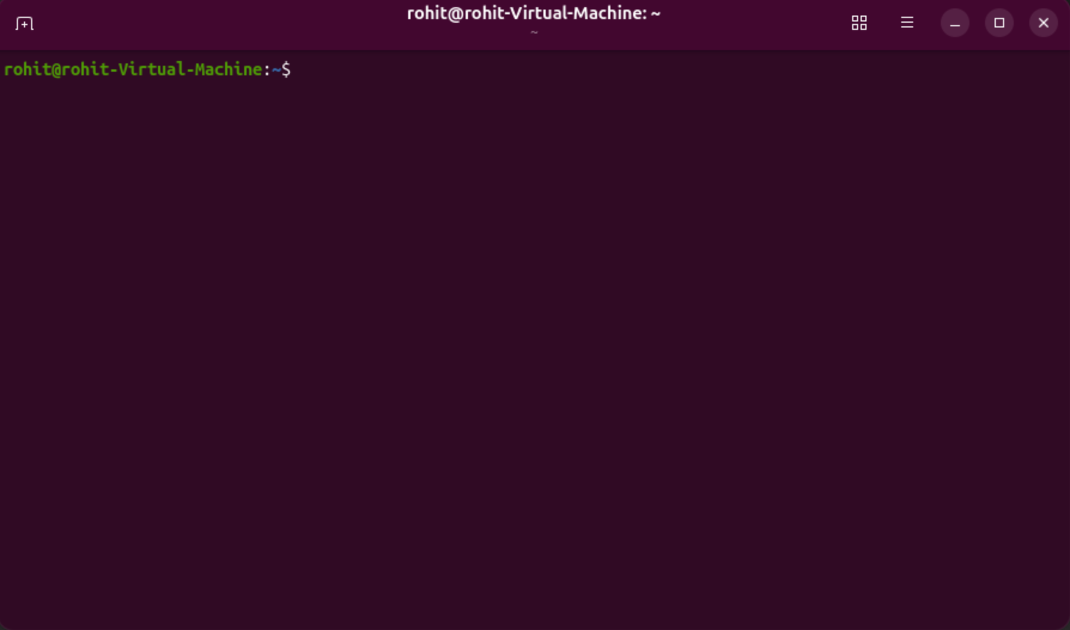
The ‘clear’ command on the terminal clears all the previous text on the terminal screen.
- 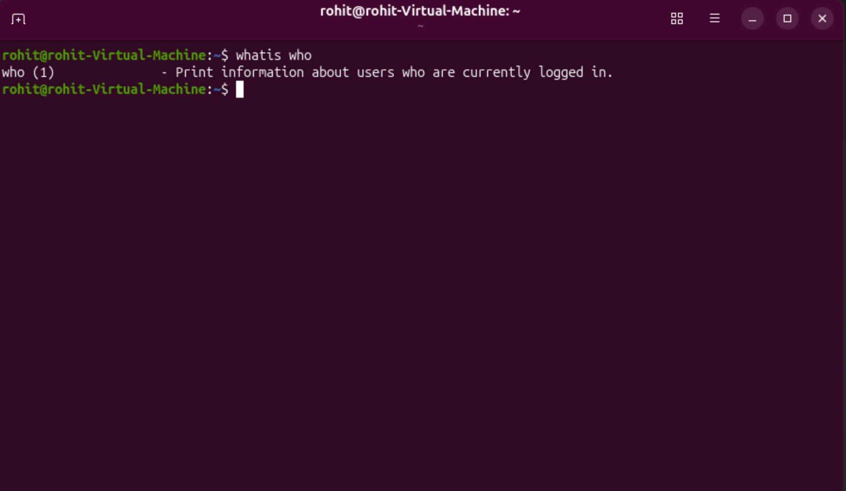
The ‘whatis who’ command produces an output that says “Print information about users who are currently logged in.”

- 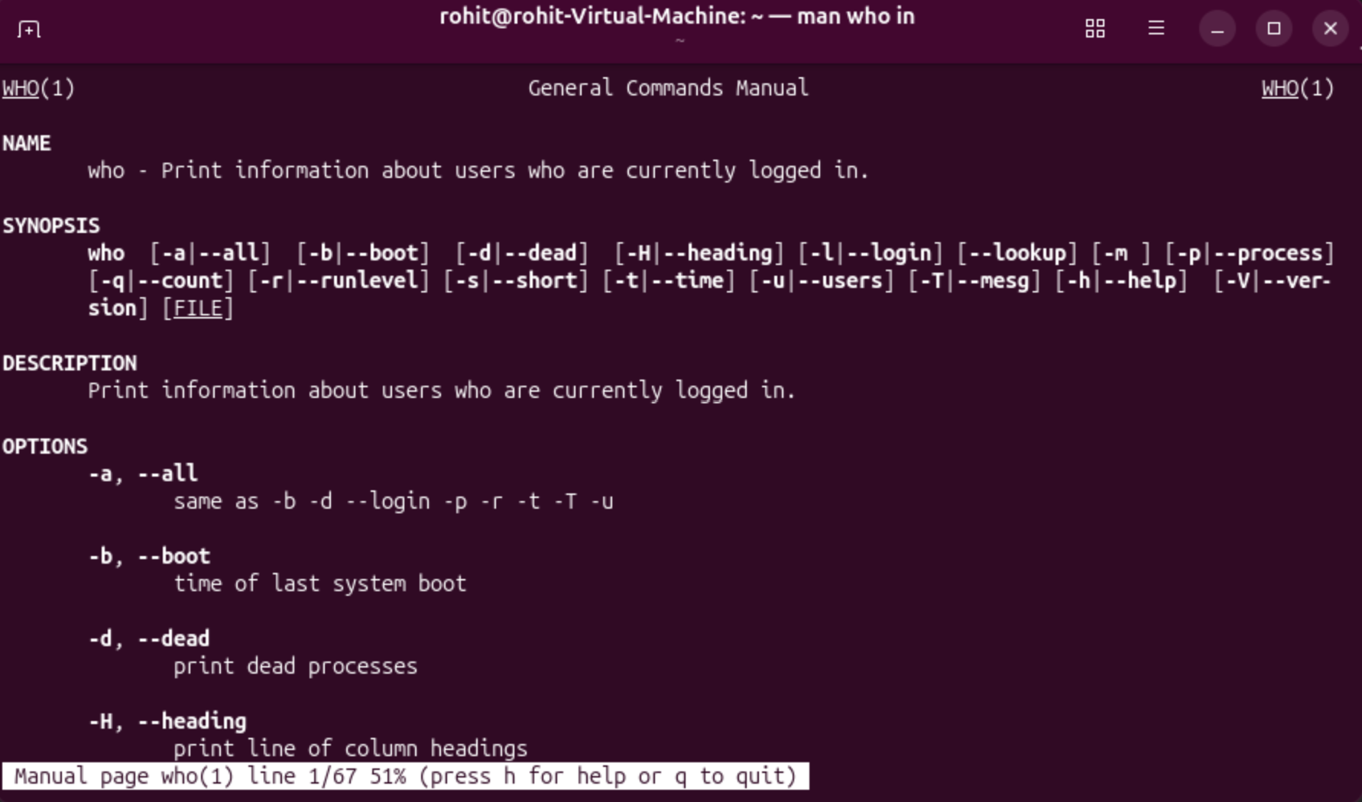
The ‘man who is’ command shows an instruction manual for most Linux commands. The spacebar and enter actions either move the cursor to the next line down, or to the end of the page.

- 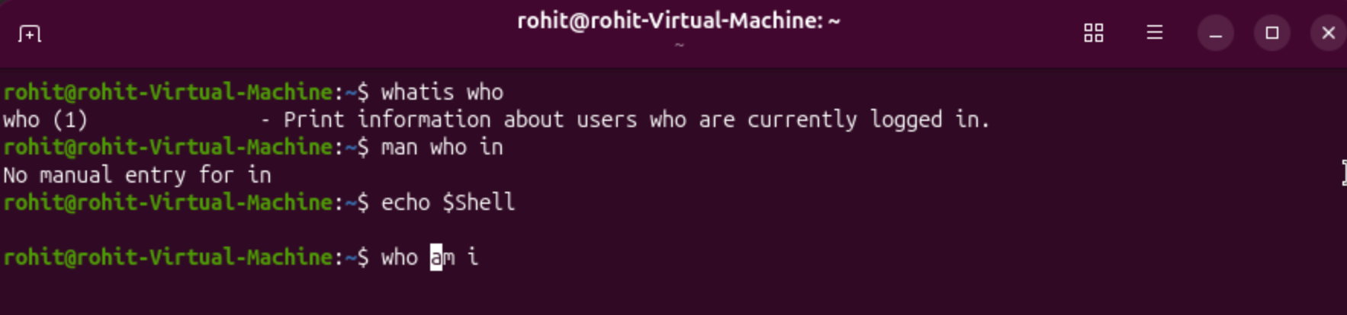
Ctrl + K deletes everything from the selected text onwards, Ctrl + B moves the cursor over one character, and Ctrl + A selects everything, although you cannot see the highlighted text.

- 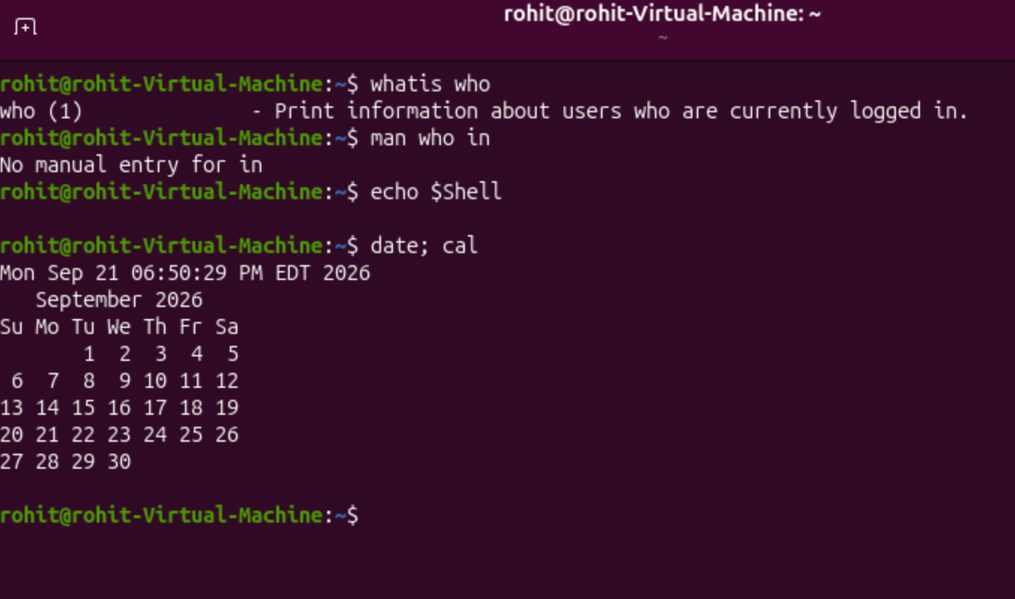
The ‘date; cal’ command produces both the date and time with the current month’s calendar.

